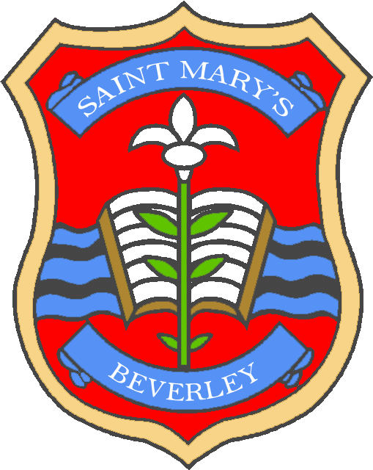

***St Mary’s CE Primary School***

**‘Nurturing Success’**

**Governor Record of Visit**

|  |  |  |  |
| --- | --- | --- | --- |
| Name of Governor |  | Area of responsibility |  |
| Date |  | | |
| Focus of visit |  | | |
| Classes/areas visited |  | | |
| Summary of what was learned and action to be taken as a result of visit, including timescale |  | | |
| Points to take forward for discussion at relevant governing body meeting |  | | |
| Evidence seen of school’s key values (Respect, Wisdom, Friendship, Hope, Trust, Perseverance) |  | | |
| Evidence of effective safeguarding practice |  | | |

Signed…………

Name………